Press Release
Invasive Species (Eurasian Watermilfoil) Discovered in Area Lakes
Public Asked to Clean Drain Dry Boats & Trailers
For Immediate Release:
Contact; {: Name: Title: Email}
{City} – Eurasian watermilfoil has recently been discovered in area waters. The public is asked to be aware and help prevent the spread by taking extra precautions to Clean Drain and Dry all watercraft and equipment. Eurasian watermilfoil is a rapidly growing weed and it can ruin habitat for fish and wildlife, destroy swimming areas and make boat travel difficult. Because it is easily transported by boats, trailers, docks and lifts, boaters and property owners are asked to be vigilant in helping to prevent the spread.
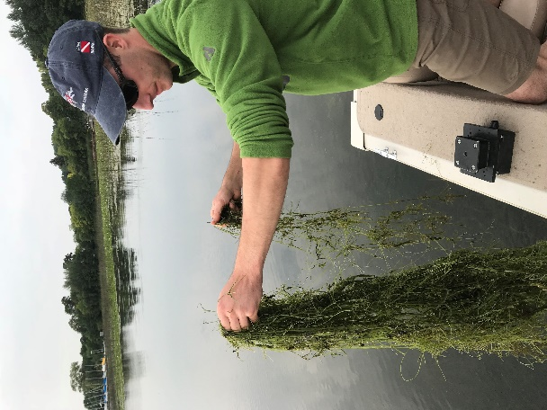
“Milfoil is a menace to our lakes; it’s critical people work together to prevent the spread and always Clean Drain Dry all water related equipment before transporting and moving to other waters. Docks, lifts and rafts along with boats and trailers can harbor invasive species. Help spread the word, not the Weeds,” said {Name, Title, Organization}.
Invasive species are non-native plants, animals and pathogens that cause damage to the ecosystem by disrupting natural food webs. They can reproduce rapidly because of no natural predators. Displacing native plants and animals, invasive species are a leading cause for threatened and endangered species. Invasives have been known to cause damage to personal property and significantly reduce property values when infestations occur.
“Preventing the spread and introduction of new species is critical. Clean Drain and Dry all water related gear and equipment. Please help your community by informing others and working together to protect our natural resources,” said Pat Conzemius, President & CEO of Wildlife Forever.
For more information on invasive species, visit: www.CleanDrainDry.org or {your organizations URL}
The Clean Drain Dry Initiative™ is the national campaign to educate the public on how to prevent the spread of invasive species. Strategic communications, marketing, outreach and educational services provide access to consistent messaging, and resources for implementing AIS prevention programs.
To learn more about prevention services and resources for your community, contact Dane Huinker at DHuinker@Wildlifeforever.org.
About {your organization}

About Wildlife Forever (WF): Wildlife Forever’s mission is to conserve America's wildlife heritage through conservation education, preservation of habitat and management of fish and wildlife.
Learn more about the award-winning programs, including work to engage America’s youth, at www.WildlifeForever.org. Donate today to help prevent the spread.

###

