Press Release
Invasive Species (Invasive Carp) Discovered in Area Lakes
Public Asked to Trash Unused Bait
For Immediate Release:
Contact; {: Name: Title: Email}
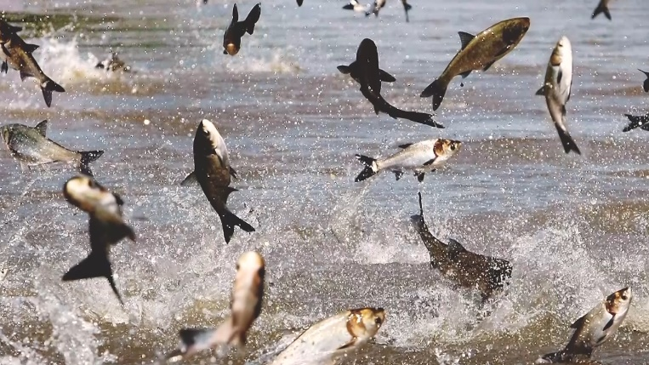
{City} – Invasive carp have recently been discovered in area waters. The public is asked to be aware and help prevent the spread. As juvenile fish, invasive carp look very similar to shad and other baitfish so it’s critical that anglers put unused bait in the trash to prevent further spread. Invasive carp outcompete native fish for food and water habitat. They have no natural predators in our region and can reproduce rapidly.
“Carp have been the scourge of America’s lakes and rivers for nearly a century. Anglers are an important line of defense in preventing invasive fish, plants and diseases from spreading. Most bait purchased in {your state} comes from certified suppliers however collecting bait for personal use is not restricted. Several carp species are found throughout state waters. Wildlife officials encourage all anglers to Trash Unused Bait to prevent accidental release of carp and potential fish diseases. Help spread the word, not the Carp,” said {Name, Title, Organization}.
Invasive species are non-native plants, animals and pathogens that cause damage to the ecosystem by disrupting natural food webs. Invasive species are a leading cause for threatened and endangered species they have been known to cause damage to personal property and significantly reduce property values when infestations occur.
“Preventing the spread and introduction of new species is critical. Clean Drain and Dry all water related gear and equipment and trash any unused bait. Please help your community by informing others and working together to protect our natural resources,” said Pat Conzemius, President & CEO of Wildlife Forever.
For more information on invasive species, visit: www.CleanDrainDry.org or {your organizations URL}
The Clean Drain Dry Initiative™ is the national campaign to educate the public on how to prevent the spread of invasive species. Strategic communications, marketing, outreach and educational services provide access to consistent messaging, and resources for implementing AIS prevention programs.
To learn more about prevention services and resources for your community, contact Dane Huinker at DHuinker@Wildlifeforever.org.
About {your organization}

About Wildlife Forever (WF): Wildlife Forever’s mission is to conserve America's wildlife heritage through conservation education, preservation of habitat and management of fish and wildlife.
Learn more about the award-winning programs, including work to engage America’s youth, at www.WildlifeForever.org. Donate today to help prevent the spread.

###

